Assignment 3

1. 1) LST: (1, 2, 3, 5, 4, 7, 8, 10, 11, 9, 6, 12)

LFT: (1, 2, 3, 7, 4, 5, 10, 6, 8, 9, 11, 12)

MSLK: (1, 2, 3, 8, 5, 4, 9, 7, 10, 11, 6, 12)

MTS: (1, 7, 2, 3, 4, 5, 10, 6, 8, 9, 11, 12)

GRPW: (1, 2, 3, 5, 4, 8, 7, 10, 11, 9, 6, 12)

GRPW\*: (1, 2, 3, 5, 7, 4, 10, 8, 11, 9, 6, 12)

GCUMRD: (1, 2, 5, 3, 4, 9, 6, 8, 7, 10, 11, 12)

2)

* Forward Planning (Serial)

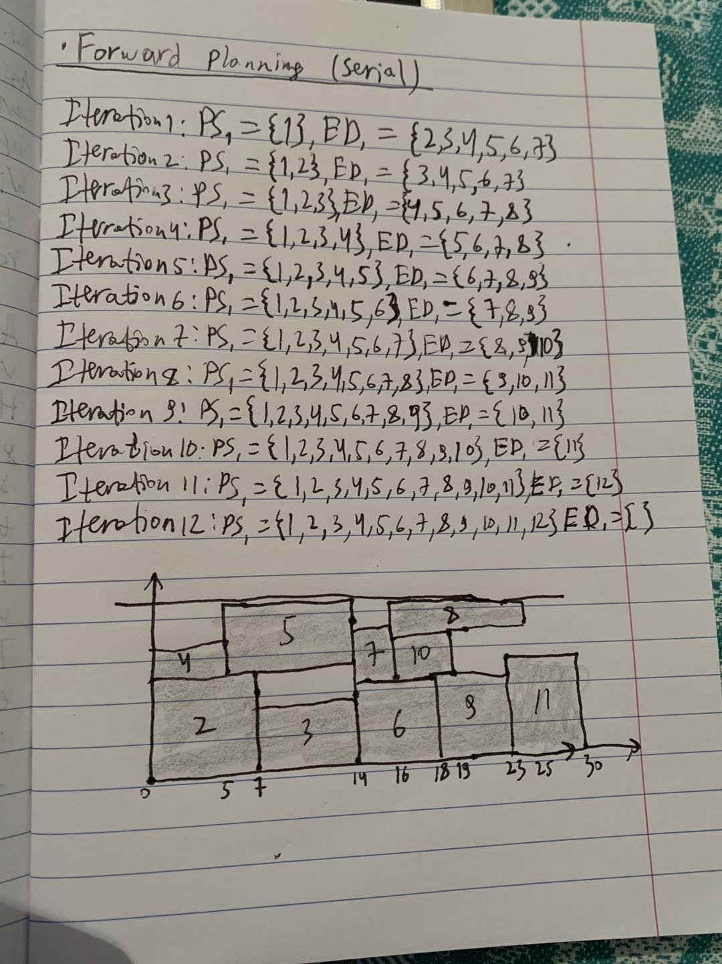

* Forward Planning (parallel)

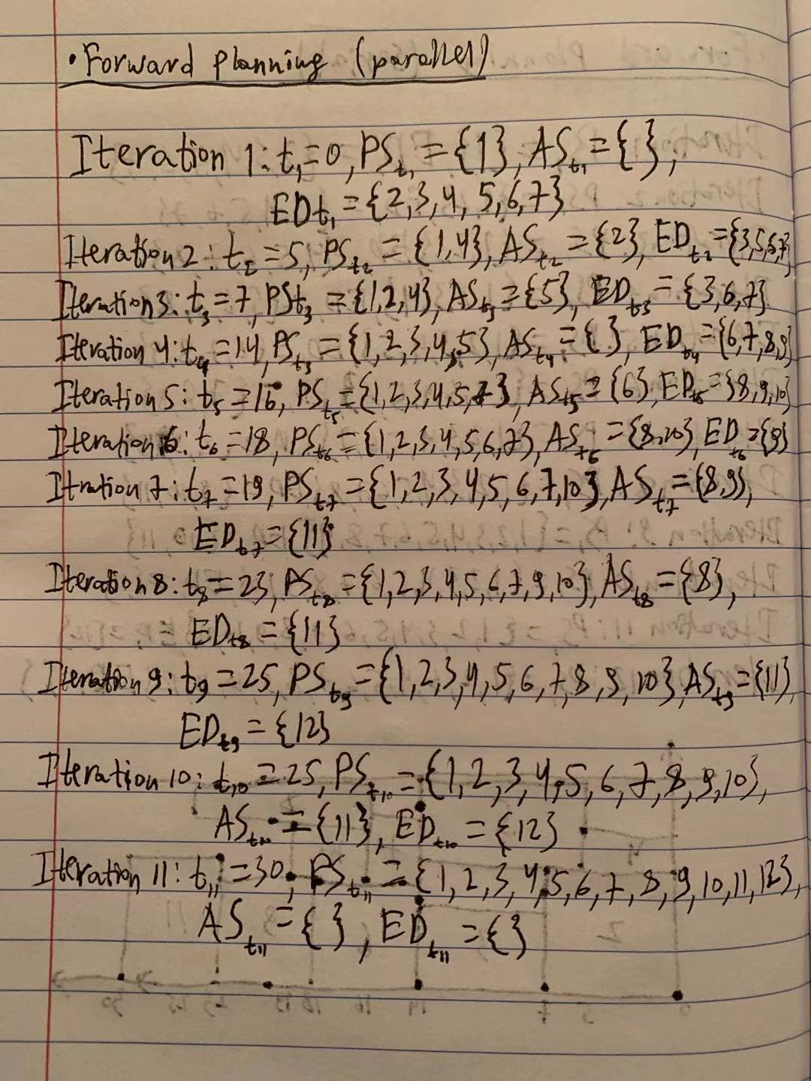

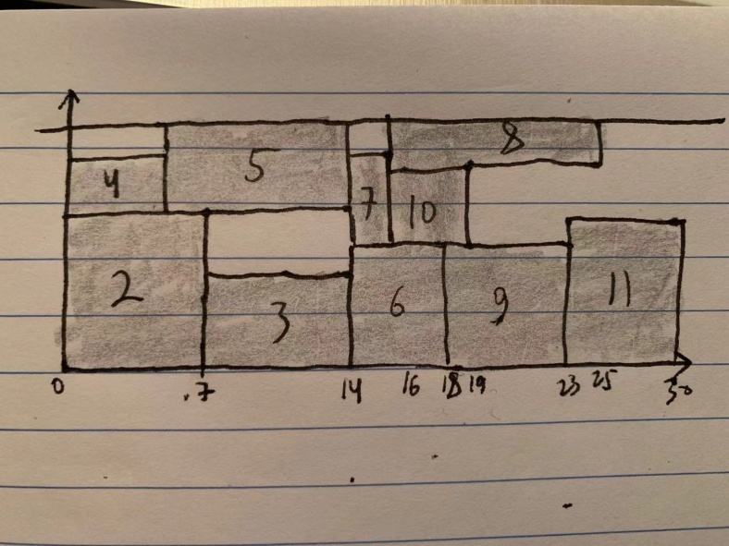

* Backward Planning (serial)

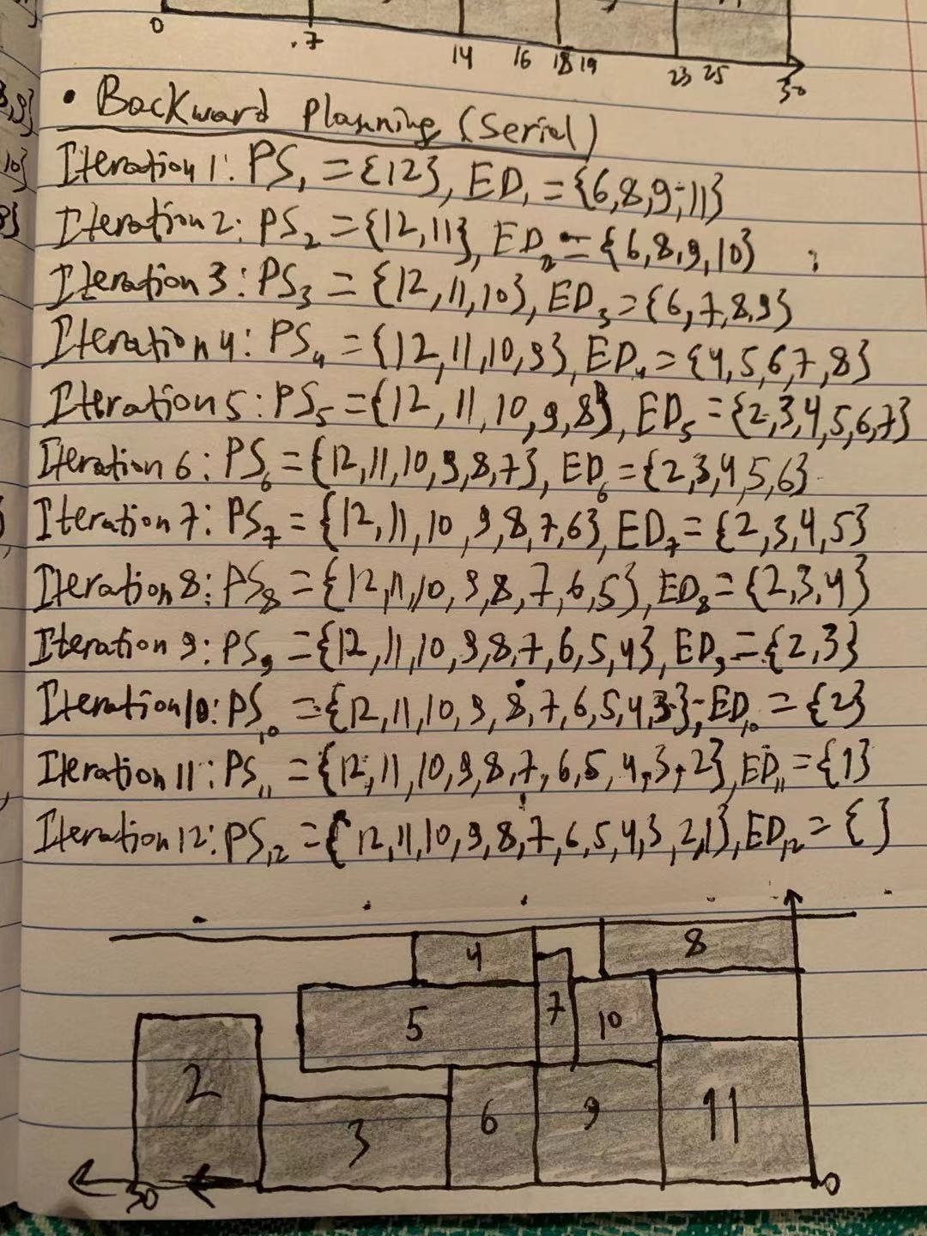

* Backward Planning (parallel)

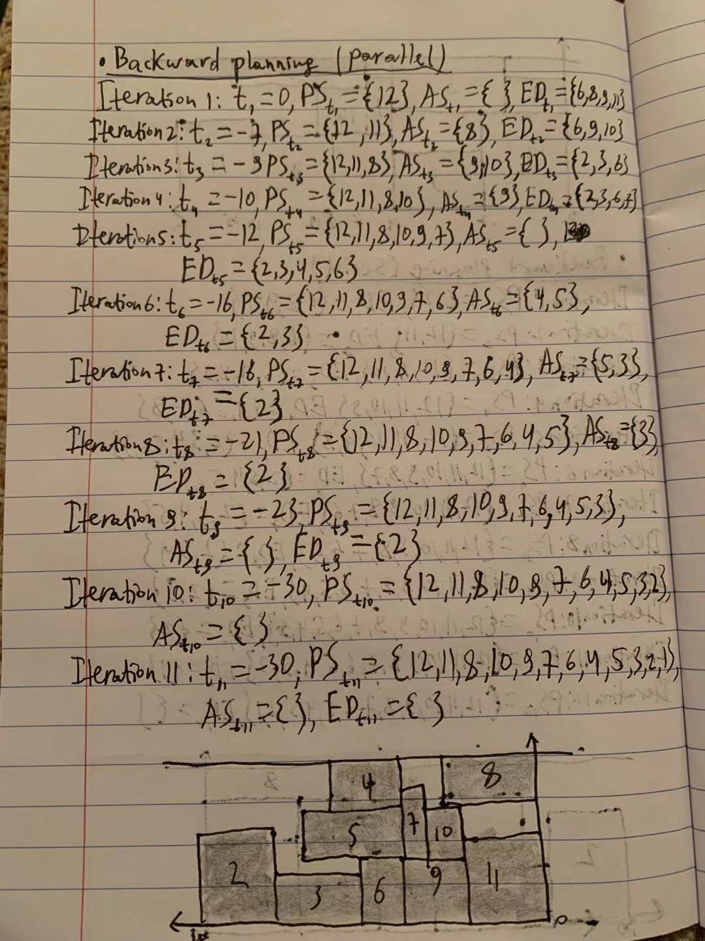

1. 1) 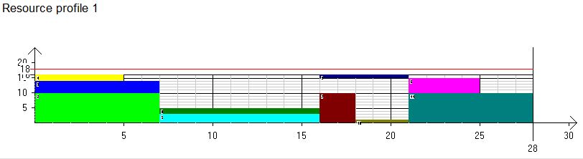

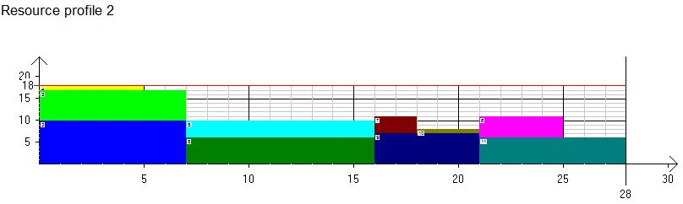

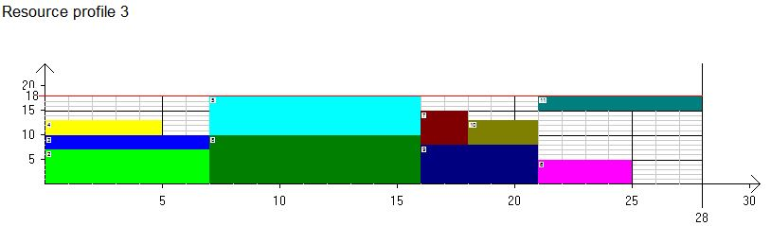

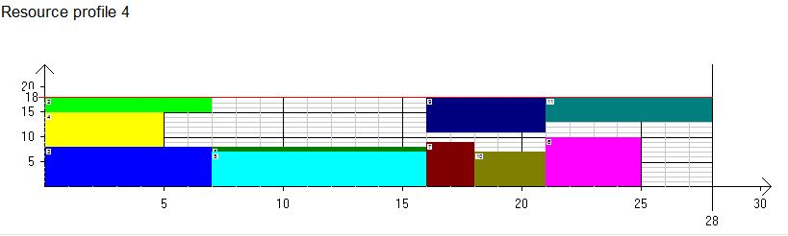

2) 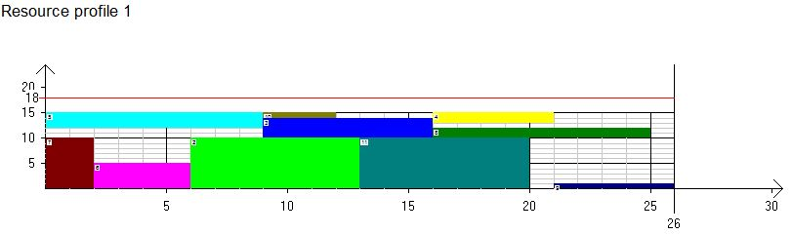

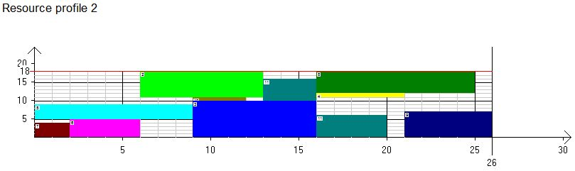

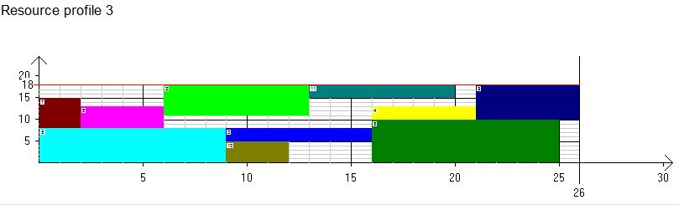

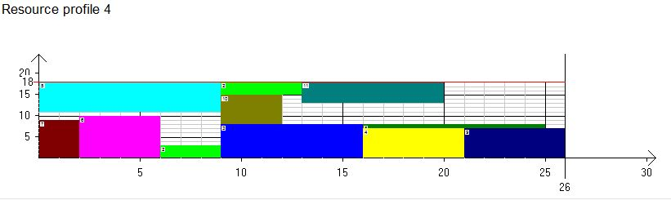

3. 1)

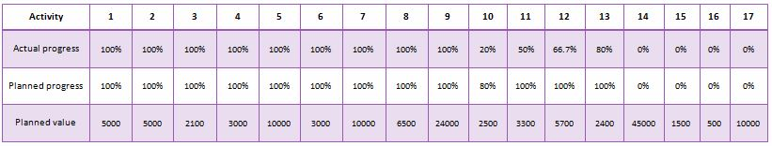

EV=5000+5000+2100+3000+10000+3000+10000+6500+24000+2500×0.2+ 3300×0.5+5700×0.667+2400×0.8=76470

PV=5000+5000+2100+3000+10000+3000+10000+6500+24000+2500×0.8+ 3300+5700+2400=82000

SV = EV – PV = 76470−82000= -5,530 < 0

SPI = EV/PV = 76,470/82,500 = 0.93 < 1

Project is Delayed.

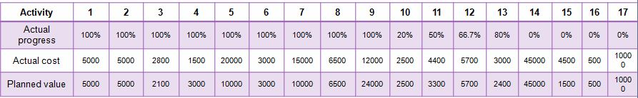2)

EV = 5000+5000+2100+3000+10000+3000+10000+6500+24000+2500×0.2+ 3300×0.5+5700×0.667+2400×0.8=76470

AC=5000+5000+2800+1500+20000+3000+15000+6500+12000+2500×0.2+ 4400×0.5+5700×0.667+3000×0.8=79700

CV = EV – AC = 76,470 – 79,700 = -3230< 0

CPI = EV/AC = 76,470/79,700 = 0.93 < 1

Project is budget overrun.